**Updated October 2024**

Dear University of Maryland Campus Community:

The University of Maryland's reputation as a premier research institution depends upon our efforts to meet the highest standards for integrity in all research endeavors. To that end, the University provides our research community with the support, education, and resources necessary to ensure a culture of research integrity.

In July of 2022, the University implemented enhanced gift acceptance processes and procedures to meet the required Federal and State standards, including National Security Presidential Memorandum-33 (NSPM-33).

At that time, the University’s research-related gift acceptance process was redesigned to address the increasing federal scrutiny of conflicts of interest (COI) and conflicts of commitment (COC) related to the research enterprise.

The processes below are required for each research-related gift received by the University and/or the University of Maryland College Park Foundation.

* All research-related gifts must be submitted to the **Kuali Build’s (KB)**[***Research Gifts Routing***](https://usmd.kualibuild.com/document-list/622a2a8dc9dc3824f7f6d2b6) **module**. Information provided will be reviewed and a determination made as to whether these funds shall be considered a gift or a grant. Gifts include funding and/or resources, for example, but not limited to: equipment, materials, software, and other items.
* Research-related gifts that *specifically name a researcher(s)* must be disclosed for COI review via the***Integrated External Relationship Portal* (**[**inTERP**](https://usmd.kualibuild.com/app/64ba9a59e3aad200fec6d0b4/page/64ba9a59e3aad200fec6d0b3/document-list)) under these conditions:
* All gifts that come through the Foundation, no matter the dollar amount, must be disclosed via inTERP.
* All gifts of $1000 or more that come through Unit Donation Pages must be disclosed via inTERP.
* Research-related gifts to a University Unit/Office, e.g., unit head/director/dean, must be disclosed in the KB [*Research Gifts Routing*](https://usmd.kualibuild.com/document-list/622a2a8dc9dc3824f7f6d2b6) module but DO NOT have to be disclosed via inTERP.
* Instead, to avoid Institutional Conflicts of Interest, the University Unit/Office must certify they will form a Gift Distribution Committee of at least three people to determine how gift funds will be distributed. The Unit Head/Dean may be a member of the committee. A Gift Distribution Committee may deal with multiple gifts.
* Additional review processes may be required depending on the type of gift received.

In some cases, gifts that support research must also be disclosed in US federal research proposals.

* If the gift is designated for a specific project, it may need to be disclosed in current and pending forms.
* If the gift supports a general area of research, it should be disclosed in biographical sketches.
* Contact the Research Transparency and Outreach office (research.umd.edu/rto) with questions about disclosing gifts in federal proposals.

The chart below outlines the process for gifts made to the Foundation ($0 threshold) and those made through donation pages on UMD websites ($1000 threshold).

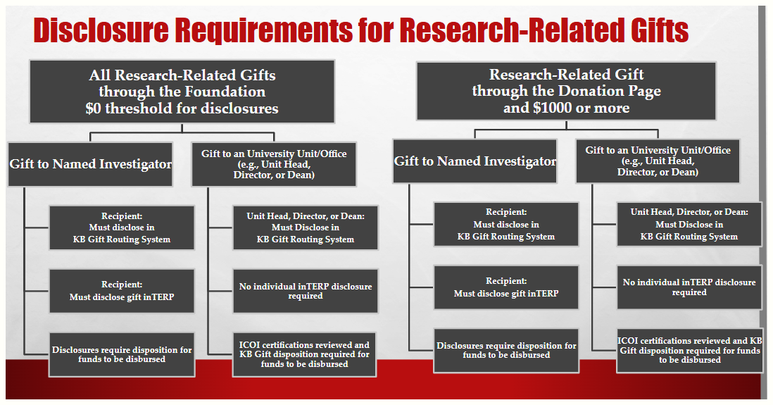

The [University’s COI website](https://research.umd.edu/coi/faq#Gifts) has an FAQ section that provides an example of the information required to be disclosed prior to gift acceptance.

**Important reminders**:

* University employees are also State employees and subject to State Ethics Laws that generally restrict the interests and relationships a University employee may have with any external entity that does or seeks to do business with the University. State Ethics Law provides a limited exemption (the “research carve-out”) to the prohibition on these relationships if, and only if, they (1) relate to research and development and (2) are fully and accurately disclosed and managed pursuant to the University’s COI/COC policies and procedures, which are approved by the State Ethics Commission.
* COIs and/or COCs that arise due to relationships between University employees and external entities that are not related to research and development cannot currently be managed and mitigated through the standard KCOI process and may need to be handled directly with the State Ethics Commission.
* State Ethics Law also contains other provisions that apply to all University employees regardless of the research carve-out. These provisions limit or prohibit State employees from participating in matters in which they (or certain family members or business entities) have an interest; soliciting and/or accepting gifts, including payment of travel and lodging expenses; using the prestige of their office or their institution’s resources, including confidential information, for private gain (their own or that of another); and representing external parties in State matters for contingent compensation.
* Please contact the University’s Office of General Counsel with questions about State Ethics Law.

We appreciate your efforts to bring in gifts and other funding to support the University’s research enterprise while also remaining compliant with Federal and State laws, regulations, and procedures. We are most grateful to all our faculty and staff who support and advance the University’s research mission.

The July 2022 memo can be found [here](https://www.ora.umd.edu/sites/default/files/2024-01/Gifts_vs_Grant.combined.pdf) and on ORA’s website.